
Unit overview
This unit of work guides students through the development of their Software engineering project. It should be integrated with other focus areas to support students to apply deeper knowledge, understanding and skills in an area of personal interest. Students develop the knowledge, understanding and skills associated with project development, including identifying and defining requirements, research and planning approaches and issues, producing and implementing software solutions and testing and evaluating code and engineering solutions.
Throughout this sequence of learning, students have opportunities to seek feedback to inform the development of their project. The Software engineering project is developed in the classroom under the supervision of the teacher using explicit teaching methods outlined in this Teacher Support Resource (TSR).

Identifying and defining
Students develop a project proposal. This includes reflection upon personal interest and their success with projects from Year 11 focus areas (Programming fundamentals, Object-oriented paradigms and Programming mechatronics). Students preview syllabus content for upcoming focus areas (Secure software architecture, Programming for the web and Software automation). They identify, define and analyse the requirements of a problem (or opportunity). Students explore tools used to develop ideas and generate solutions and investigate types of software implementation methods. They contact and interview a client as well as analyse software engineering case studies, scenarios and existing solutions.

Research, planning and issues
Students research and use the Waterfall, Agile and WAgile software development approaches. They apply project management skills to plan and conduct the development and implementation of their software engineering solution. Students explore social and ethical issues associated with project work, including working individually, collaboratively and responding to stakeholders. They explore communication issues associated with project work and investigate how software engineering solutions are quality assured. Students demonstrate the use of modelling tools and explain the contribution of back-end engineering to the success and ease of software development.

Producing and implementing
Students construct and implement a solution to a software problem or opportunity using (an) appropriate development approach(es). They construct and document algorithms, demonstrate the use of programmed data backup, implement version control and explore strategies to respond to difficulties when developing their solution. Students propose an additional innovative solution using a prototype and user interface (UI) design.

Testing and evaluating
Students apply methodologies to test and evaluate code. They use a language-dependent code optimisation technique, analyse and respond to feedback and evaluate the effectiveness of a software engineering solution.
The software engineering solution is evaluated and tested to ensure its features meet the success criteria outlined in the problem definition and identified needs.
Students present their software engineering solution using presentation software to the class (and client) and submit the project documentation and code.

Assessment task overview
Type of task: develop a software engineering project containing a solution, project documentation and a presentation.
Outcomes being assessed:
A student:
- justifies methods used to plan, develop and engineer software solutions SE-12-01
- applies structural elements to develop programming code SE-12-02
- analyses how current hardware, software and emerging technologies influence the development of software engineering solutions SE-12-03
- evaluates practices to safely and securely collect, use and store data SE-12-04
- explains the social, ethical and legal implications of software engineering on the individual, society and the environment SE-12-05
- justifies the selection and use of tools and resources to design, develop, manage and evaluate software SE-12-06
- designs, develops and implements safe and secure programming solutions SE-12-07
- tests and evaluates language structures to refine code SE-12-08
- applies methods to manage and document the development of a software project
SE-12-09
Software Engineering 11–12 Syllabus © NSW Education Standards Authority (NESA) for and on behalf of the Crown in right of the State of New South Wales, 2022.
Suggested weighting: 30%
Students identify a real-world problem or opportunity that can be addressed through the development of a software engineering project. Students develop project documentation and engineer a software solution that addresses this real-world problem or opportunity. The software engineering project is presented to the class by simulating a client handover.

Project description

Students find a client for whom they can develop a software solution. Students unable to find a client may use Scenario 1 or Scenario 2 in the Student support material section of the assessment task.
Possible clients include:
- school-based positions: a teacher, librarian or school administrator
- a member of the wider community
- business owner
- a non-government organisation (NGO) that works on various humanitarian and social issues
- a sporting club, coach, manager or gym
- a PCYC, YMCA, Scouts, Guides or similar
- a community group, religious group or hobby group
- any other organisation or client approved by the teacher.
Students meet and negotiate with their client to:
- define and analyse requirements
- assess scheduling feasibility
- define boundaries
- continually check progress
- document all correspondence.

Note: students ensure their classroom teacher is involved in all contact and correspondence between themselves and their clients. This strengthens school partnerships to ensure a quality learning experience for the student and a quality software product for the client. It is the students’ responsibility that both course and client requirements are met. School-defined submission dates and client requirements will assist in determining the scale and scope of the final project.
The software solution:
- demonstrates the design, development and construction of algorithms
- addresses all the clients functional and performance requirements.
The solution should also:
- use a language-dependent code optimisation technique
- be configurable in terms of the interface layout, colour scheme, accessibility requirements, legislative and technical requirements as per client needs
- incorporate security elements such as usernames, passwords, basic encryption and decryption as per client requirements
- include a proposal for an additional innovative solution using a prototype and user interface (UI) design.

Submission details
Students submit:
Component A – project documentation
Complete resource booklet including:
- process diary
- client correspondence and feedback
- Gantt chart
- use of modelling tools.
Component B – software solution
- Develop, code and upload a software solution for the problem as indicated in the project documentation.
Component C – presentation
- Present their software engineering project to peers
- Respond to Q&A.

Steps to success
Table 1 – assessment preparation schedule
Steps | What I need to do
Component A –  Project documentation | Ongoing completion of the Software engineering project documentation booklet provided that involves 4 key stages.  - Identifying and defining  - Research and planning  - Producing and implementing  - Testing and evaluating
Identifying and defining | - Begin by defining and analysing the problem requirements including:  - demonstrating need(s) or opportunities  - assessing scheduling and financial feasibility  - generating requirements including functionality and performance  - defining data structures and data types  - defining boundaries  - Provide ongoing screen shots of tools used to develop ideas and generate solutions including:  - brainstorming, mind mapping and storyboards  - data dictionaries  - algorithm design  - code generation  - testing and debugging  - installation  - maintenance.
Research and planning | - Apply ongoing project management to plan and conduct the development and implementation of the project including:  - scheduling and tracking using a software tool, including Gantt charts  - using collaboration tools  - Explore communication issues associated with project work including:  - involving and empowering the client  - enabling feedback  - negotiating  - Investigate how software engineering solutions are quality assured including:  - defining criteria on which quality will be judged  - ensuring requirements are met using a continual checking process  - addressing compliance and legislative requirements  - Demonstrate the use of modelling tools including:  - data flow diagrams  - structure charts  - class diagrams  - decision trees.
Component B –complete software solution | - Develop and code a software solution for the problem as indicated in the project documentation  - Upload the solution.
Producing and implementing | - Design, construct and implement a solution to a software problem using appropriate development approach(es)  - Develop, construct and document algorithms  - Implement version control when developing a software engineering solution  - Propose an additional innovative solution using a prototype and user interface (UI) design.
Testing and evaluating | - Apply methodologies to test and evaluate code  - Use a language-dependent code optimisation technique.
Component C – presentation | - Present their software engineering project to peers  - Respond to questions and answers.
Testing and evaluating | - Analyse and respond to feedback  - Evaluate the effectiveness of a software engineering solution.

The design and production process
Throughout your study of Software engineering, you will learn about different types of design processes and how to apply them in your design project.
The design and production process:
- involves a sequence of organised steps which provide a solution to design needs and opportunities
- may take a few seconds or minutes, such as when you select what clothes to wear, or may take years as in the case with the design of a motor vehicle
- may involve one person or may involve many people
- may be simple or complex, depending on the task
- involves questioning (or evaluating) throughout the iterative process.
Figure 2 – flowchart of design and production process
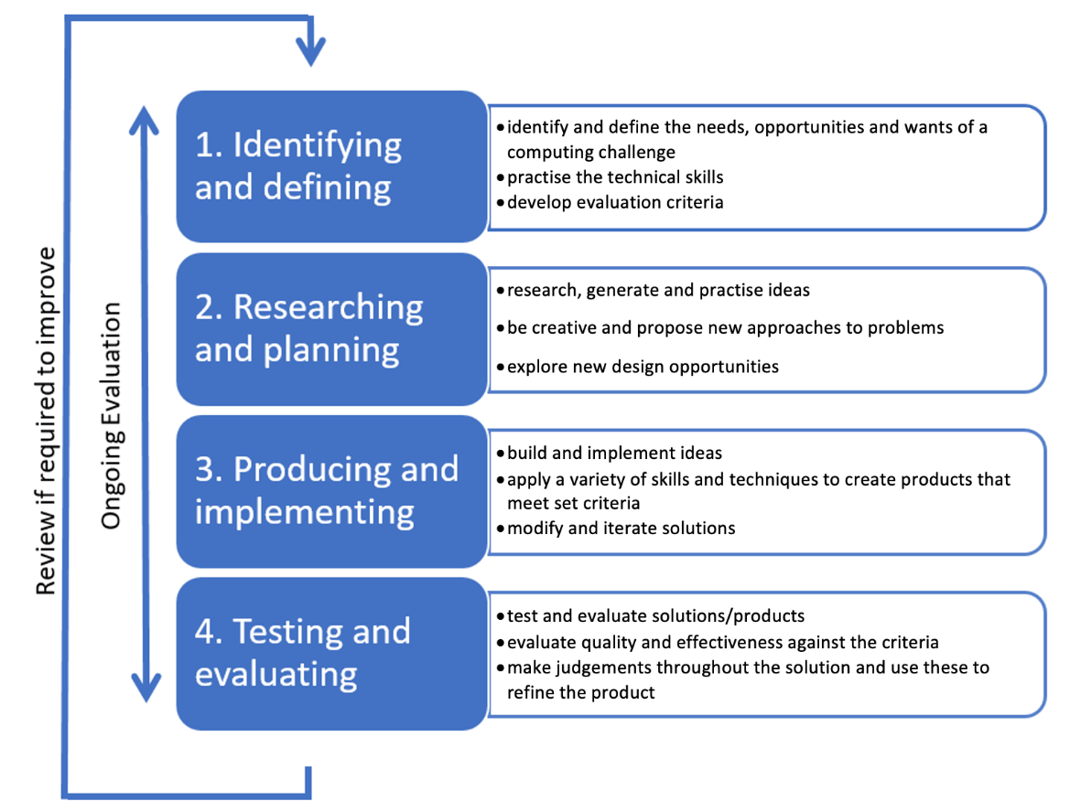

1. Identifying and defining

Define and analyse problem requirements

Discuss with the client their needs and propose further opportunities. These will include the functional and performance requirements. In the table below describe the need(s) and opportunities that the software solution will provide for the client.
Need | Opportunities
1 Encryption, security | 2 Synchronization across devices
2 User friendly rich text | 4 messaging/collaboration system
 | 3 Executable application
 | 1 Printing notes
Rank the needs and opportunities into priorities (‘must haves’) and opportunities (‘like to have’) by numbering the list.

Assess the scheduling and financial feasibility

- Which of the needs and opportunities will be achieved first?
- Which are dependent upon the previous completion of another?
- Will there be any cost in this project?
In consultation with the client generate a ‘requirements of the problem’ statement that includes functionality (Does it do what it is meant to do?) and performance (How well does it do it?).
Ensuring encryption and user-friendly rich text is the main priority. As a web app, it is cross platform already, but an executable application could be more useful. Synchronisation is the first opportunity, whereas the collaboration system and executable are secondary priorities.
The note taking and rich text functions are first, and encryption is second.

The application must be able to create, read, edit and delete notes which have a maximum of 2 pages. The application will use a rich text editor and file system.
Revise the use of data structures and datatypes from the Year 11 projects.
In consultation with the client, analyse the problem. The data structures and data types required will need to be defined. These are presented in data dictionaries when modelling the system.
List all of the entities (things) that will be represented and stored digitally in your software engineering solution and the data structures and data types that will be used to do so. For example:
- Users will be represented as accounts with usernames and hashed passwords (maybe also hashed usernames)
- Notes will be stored using public key encryption as local files in an encrypted format.

Boundaries

Boundaries define the limits of the problem or the system to be developed.
Defining the boundaries for the problem is essential so the client has realistic expectations of the limits of the new system.
Consider the software engineering solution and the aspects you can control.
Which parts of the problem remain outside the system (in the environment) that will interact with the system through an interface?
In the space below discuss any limitations or boundaries in which this new software will need to operate.
Limiting page count/word count-could theoretically not, but then everything would be one file which defeats the purpose of a note taking app and makes it more like MS Word. We’re writing summaries, not essays.
Cloud file systems are expensive, local is free.

Explore tools to develop ideas and generate solutions

The following tools will gather meaning as you work through this booklet. Each time you use one of these tools take a screenshot and paste it into this workbook. Add a description of its use in the table below.
Tools | Screenshot | Description
Algorithm design
Brainstorming
Code generation
Data dictionaries
Debugging
Installation
Maintenance
Mind-mapping
Storyboards
Testing

Investigate types of software implementation methods
Software implementation methods are:
- direct
- phased
- parallel
- pilot.
Each of these implementation methods has its advantages and disadvantages, and the choice depends on the specific context of the project, including its size, complexity and the organisation's risk tolerance.
Direct implementation involves switching from the old system to the new system in one single action. All users move to the new system on a set date, and the old system is retired immediately. This method is straightforward and quick but can be risky if the new system has not been thoroughly tested.
Parallel implementation means both the old and new systems run simultaneously for a period. This allows for a comparison between the 2 systems to ensure that the new system operates correctly before the old system is decommissioned. While safer than direct implementation, running 2 systems in parallel can be resource intensive.
Pilot implementation involves rolling out the new system to a small, manageable group of users before a full-scale implementation. This method allows organisations to identify any issues or necessary adjustments in a controlled environment, reducing the risk of widespread problems.
Phased implementation involves gradually implementing the new system in phases or modules. Each phase is rolled out and stabilised before moving on to the next, allowing for incremental testing, training and adaptation. This method can reduce risk and disruption but may take longer to fully implement the new system.

Figure 3 – the 4 implementation methods.

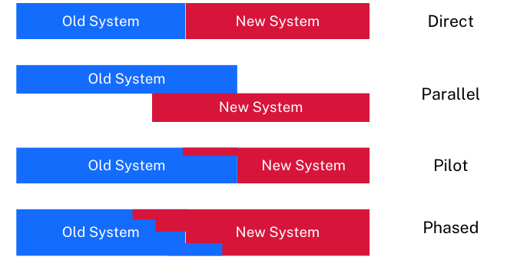
In the space below explain the applicability of the implementation method for the current project.

